Dear Sebastian,

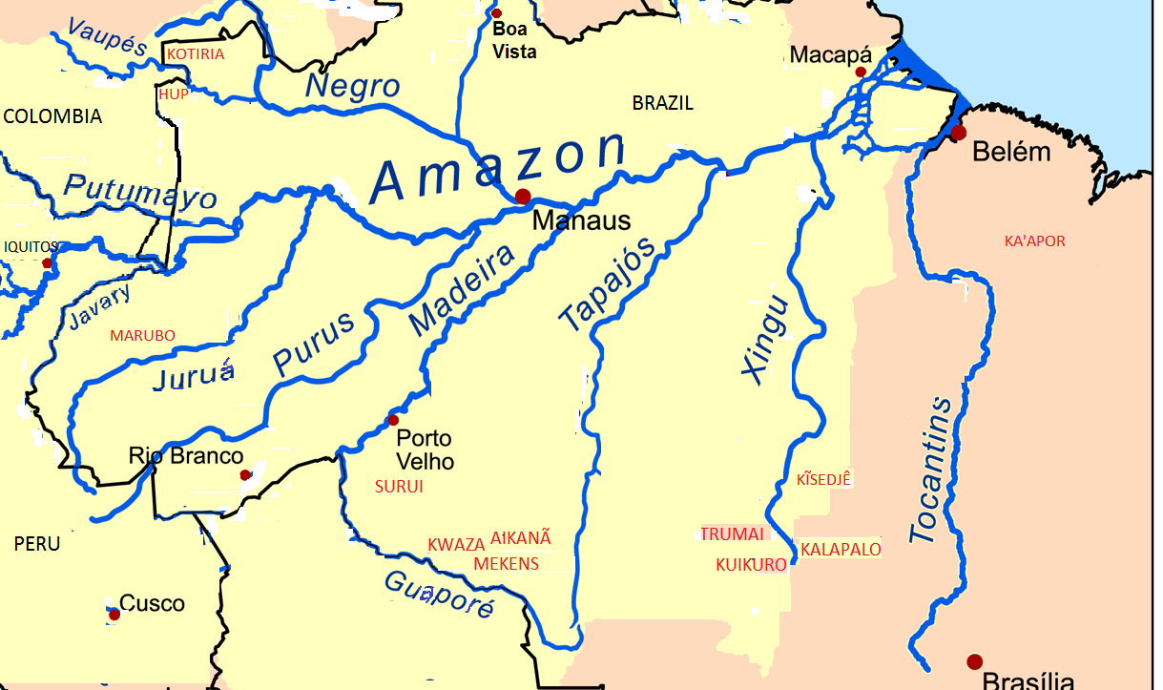Here is an approximation of what we’d like for the general map for the Amazonian texts volume. We used that base map you sent, but zoomed in a little. I don’t know if we need to have a small map of the continent with a box indicating the location of this map within it. See what you think.

The adjustments we’d like to suggest are:  
1) keep the country names about the same  
2) make the city names smaller and use a black dot for the locations  
3) keep the rivers in blue and make all the river names smaller, less than the size of the ‘Vaupes’ and ‘Javary’ as they are on this map, and use a little larger font for the Amazon   
4) use a red and bold font for the language names so that they will clearly stand out  
5) we don’t need to distinguish the Amazon basin in the background, but could perhaps use some kind of shading to distinguish Brazil from the other countries

The second map is for the Marubo chapter, and the author provided this model. It’s OK to leave off ‘river’ from the river names.

